|  |  |  |  |  |  |
| --- | --- | --- | --- | --- | --- |
| ****Project Type: NCIS Pledge a Ribbon Campaign Microsite**** | | | | ****Date:** 30 Jun 2015** | |
| ****Project Requirements:**** | ****Client’s Name:**** | | | | |
| ****Brand / Product / Campaign / Industry:**** | | | | |
| ****Deadlines** (Date / Time)**:**** | | | | |
|  |  |  | |  |
| ****Development**** | ****Internal UAT**** | ****Client UAT**** | | ****LIVE**** |
| ****Comments / Special Instructions:**** | | | | | |

1. **Basic Information**

* CMS: Wordpress
* Domain Hosting: Linux Environment
* SMTP: To be purchased (for email notfications)

1. **Sitemap**

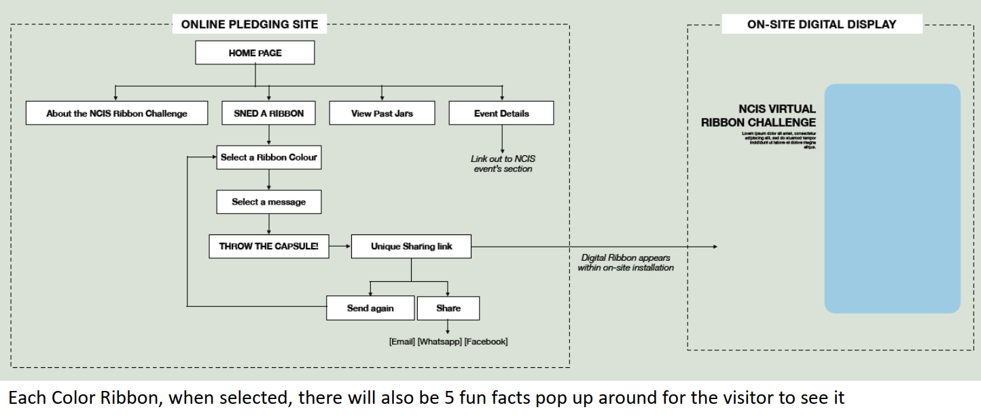

* Article page: About the NCIS ribbon challenge
* Event Details: Hyperlink to NCIS website.

1. **HOMEPAGE**

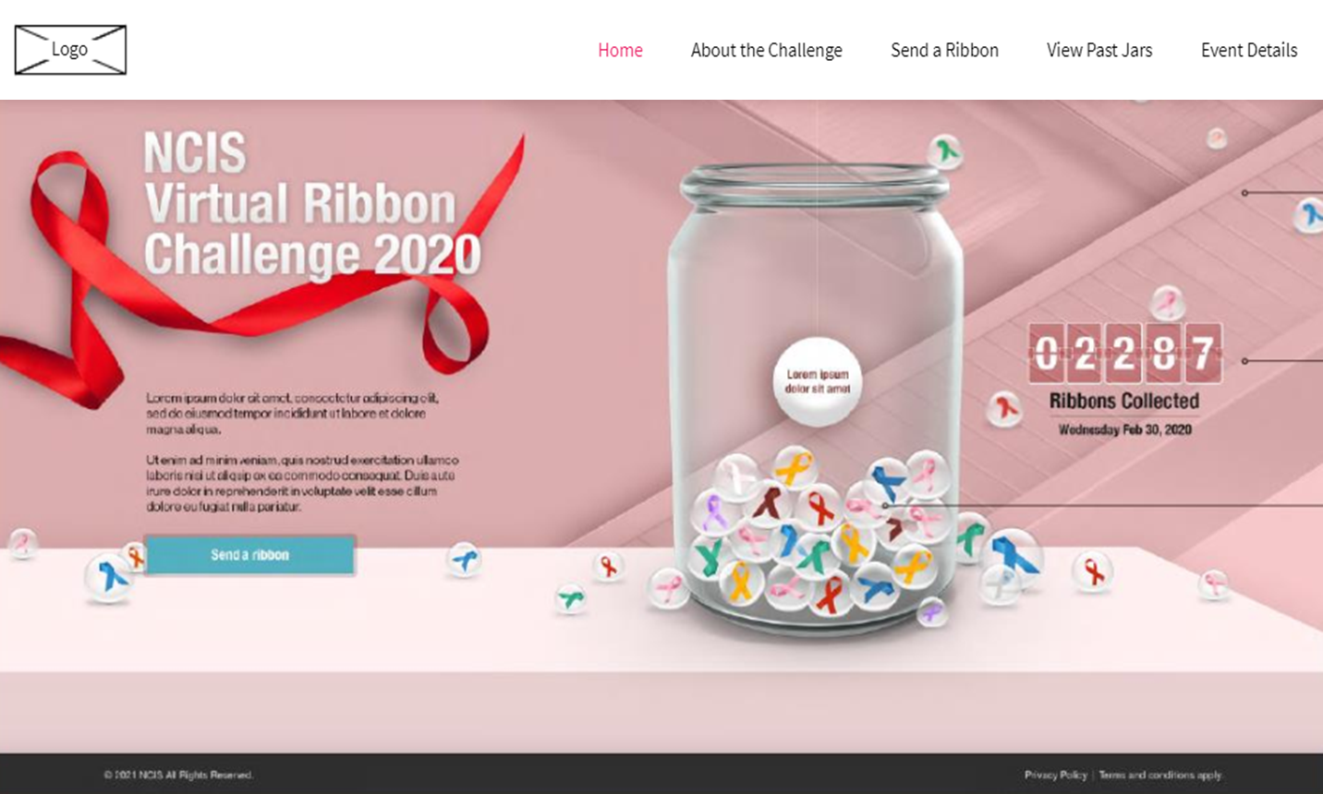

**Note: actual design may varies**

**Belt will be animation and ribbon will be moving**

|  |  |  |
| --- | --- | --- |
| **ITEM** | **SPECIFICATIONS / DETAILS** | **REMARKS** |
| **About the Pledge** | Texts |  |
| **Counter** | * Display the total no. of ribbons collected * Date |  |
| **Send a Ribbon** | * Hyperlink to Send a Ribbon page |  |
| **Footer** | * Privacy Policy & Terms of Use |  |

1. **Send a Ribbon > Select Your Ribbon and Create your Message**

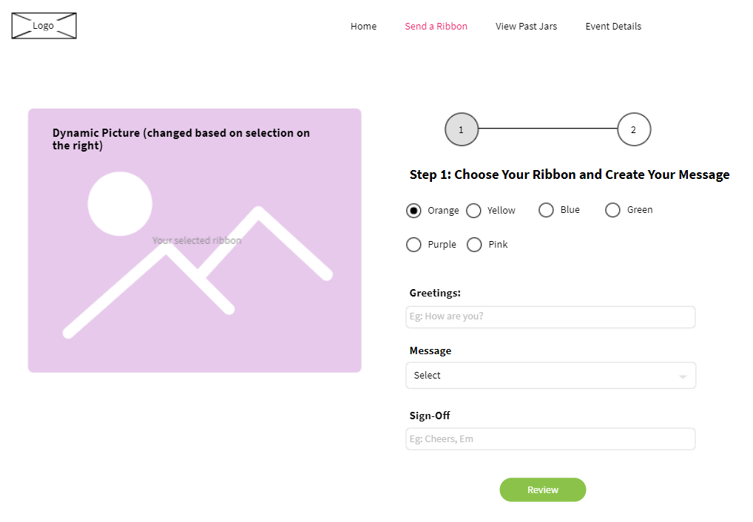

**One option can have 5 different images and 5 popup. And then will show randomized**

**Note: This is only a wireframe to confirm the functionalities of the page**

|  |  |  |
| --- | --- | --- |
| **ITEM** | **SPECIFICATIONS / DETAILS** | **REQUIREMENTS** |
| **Image on the Left** | Changed based on what was selected on the right. |  |
| **Navigation Panel** | * Indicates the no. of steps of this campaign |  |
| **Select Ribbon Color** | * Select ribbon color (radio button) * When button selected, random fun fact of the ribbon color will pop up | Please provide 5 fun facts for each color. |
| **Greetings** | * Opening message to the recipient, Eg: **How are you?** |  |
| **Message** | * Drop down selection of pre-defined messages | Please provide the messages for users to select |
| **Sign-Off** | * Closing, eg. **Cheers, Sender’s Name** |  |
| **Review** | * Click review to go to next step |  |

**Note: Recipient will receive a hyperlink to view the message on the website**

|  |  |  |
| --- | --- | --- |
| **ITEM** | **SPECIFICATIONS / DETAILS** | **REQUIREMENTS** |
| **Message in email** | Put in email | Please provide message |

Sample of the popup window of Fun Fact

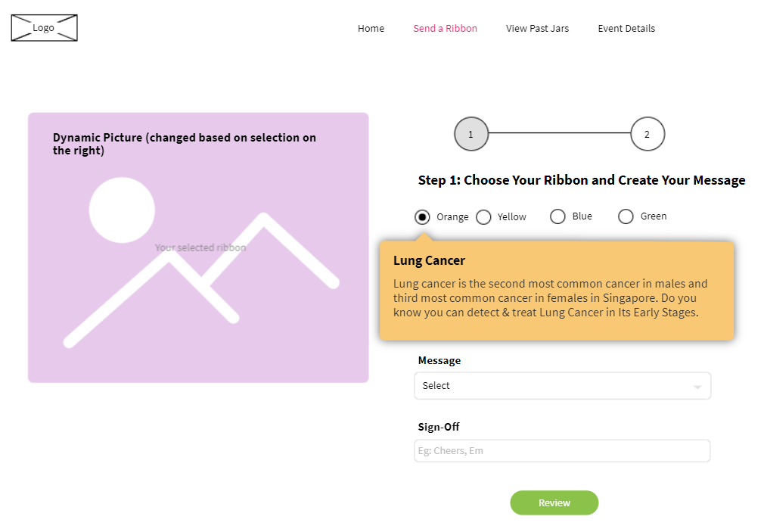

1. **Send a Ribbon > Review & Send**

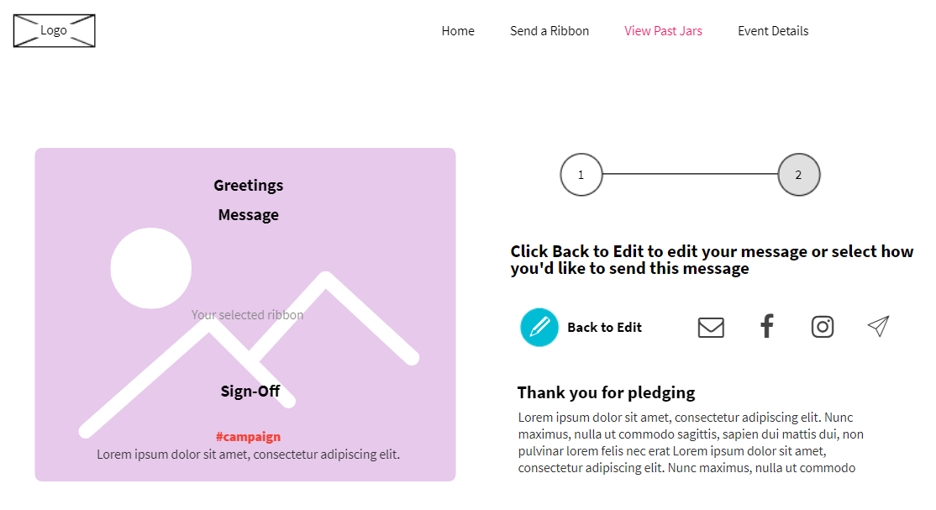

**Note: This is only a wireframe to confirm the functionalities of the page**

|  |  |  |
| --- | --- | --- |
| **ITEM** | **SPECIFICATIONS / DETAILS** | **REQUIREMENTS** |
| **Image on the left** | Dynamic based on what the user input in previous step   * Greetings * Message * Sign-off   Include a campaign hashtag and message | Please provide 5 ribbon images |
| **Edit** | * To go back and edit the message |  |
| **Sharing** | * **Email** – sender to input recipient email; recipient will receive an email with a link to view the message on website. * **Social Sharing** – Steps will be shared with sender how to send via the respective social media / Messaging channels, namely:   **Facebook, Instagram, Twitter, Telegram, Line, WeChat.** |  |
| **Thank you message** | * Thank you message to recipient. * Option to include an explainer about the campaign * Link to FormSG to input particulars to participate in the lucky draw |  |

**Note:**

**Only email function is available on kiosk**

1. **Send a Ribbon > Sharing via Facebook**

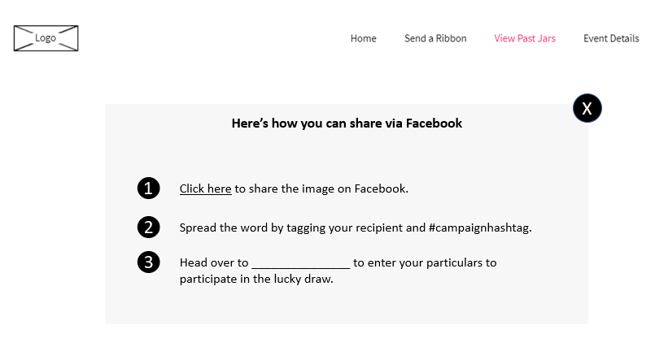

**Note: This is only a wireframe to confirm the functionalities of the page**

|  |  |  |
| --- | --- | --- |
| **ITEM** | **SPECIFICATIONS / DETAILS** | **REQUIREMENTS** |
| **Steps to share** | Depending on the channels that sender selected to share the card, respective instructions will appear |  |
| **Campaign Hashtag** |  | Please provide campaign hashtag |
| **Form URL** | Link users to FormSG to fill in the particulars | Please provide URL |

**Note:**

**This function is not available when message is created on the kiosk.**

1. **View Past Jars**

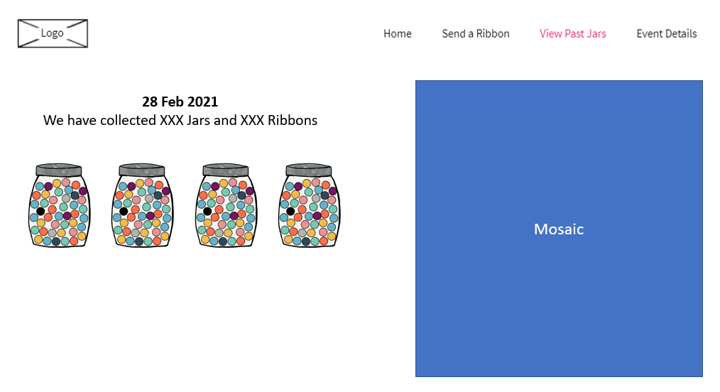

**Note: This is only a wireframe to confirm the functionalities of the page**

|  |  |  |
| --- | --- | --- |
| **ITEM** | **SPECIFICATIONS / DETAILS** | **REQUIREMENTS** |
| **Jars** | * Images of filled jars appeared | * Please provide jar design image |
| **To-Date Counter** | * Display of the number of ribbons and jars collected |  |
| **Mosaic** | * Mosaic of the final image to be displayed. * Image change from black and white to full colored at the end of the campaign |  |